Enrolment Management Plan

School Context
Teesdale Primary School educates children in the neighbourhood boundary area of Teesdale, as described below.
Policy Framework
The 2006 Education and Training Reform Act (ETRA) underpins the Department of Education and Training (DET) enrolment policy which can be found at: http://www.education.vic.gov.au
The policy states that all eligible children and young people have the right to be admitted to their designated neighbourhood government school.
School Zone
The Teesdale Primary School zone has been approved by the Minister for Education and ensures consistency with DET policy and the ETRA legislation regarding closest school.
A student's designated neighbourhood school is generally the school that is nearest the student's permanent address as determined by the school zone. The website https://www.findmyschool.vic.au provides guidance on which school zone a student's permanent residence is located within.
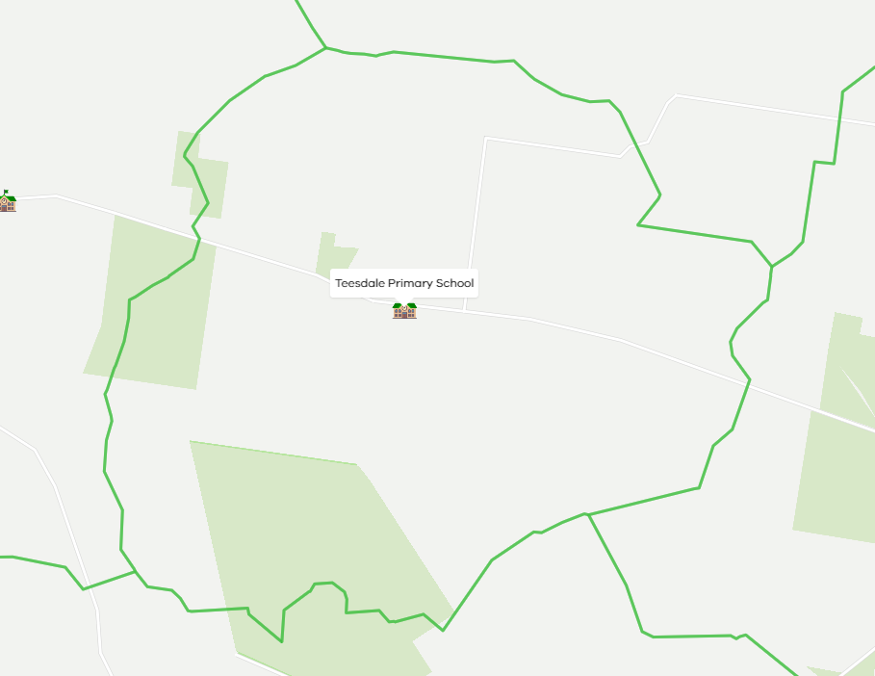

Fig 1- 2021 School Zone for Teesdale Primary School

Priority Order of Placement
The potential future demand for enrolment places from within the local community indicates that Teesdale Primary School must manage enrolments carefully and in accordance with the Priority Placement Order in the Enrolment Policy. A student’s permanent place of address determines eligibility for enrolment at Teesdale Primary School.
Where there are insufficient places at a school for all students who seek entry, students are enrolled according to the Placement Policy's priority order of placement, which has five criteria.
In circumstances when a school may not be able to accept all applications due to existing or future capacity concerns, schools must manage enrolment applications in accordance with the following priority order of placement:
1. Students for whom the school is the designated neighbourhood school.
2. Students with a sibling at the same permanent address who are attending the school at the same time.
3. Where the Regional Director has restricted the enrolment, students who reside nearest the school.
4. Students seeking enrolment on specific curriculum grounds.
5. All other students in order of closeness of their home to the school
The future capacity needs at Teesdale Primary School mean that enrolments will be confined to the first two criteria.
In exceptional circumstances, a student may be enrolled in a school based on compassionate grounds. This is an overarching consideration and does not form part of the priority order of placement.
Schools are permitted to assess and make a determination for exceptional circumstances on a case-by-case basis.
Schools must ensure that all applicants eligible under a criterion have been offered a place before moving to consideration of the next. All students for whom the school is the designated neighbourhood school are guaranteed enrolment.
If you have any questions regarding the Teesdale Primary School enrolment Management Plan, please contact the school.
Sam Irwin
Principal - Teesdale Primary School

